# ITERATION 5

## 1. ITERATION PLANNING

### Requirements Statement:

Continue to use html and js files from previous iteration. User can input a series of numbers. A rogue number set of 999 disables the input box. If the numbers are in ascending sequence, output “Series in sequence” else “Series not in sequence. If adjacent values are equal, series is still in order.

### Task Summary:

1. Design the solution to the requirement statement
2. The solution which will implement previous work done in previous iteration
3. Develop the functions required for creating the task for the user.
4. Test the functions created.

### Details and Time Estimate:

This table below sets out the tasks to complete for this iteration, the time estimated for each task and the actual time taken. The time is rounded to 10 min blocks.

|  |  |  |  |  |  |
| --- | --- | --- | --- | --- | --- |
| **Task** | **Item** | **Date start** | **Time estimate** | **Date finished** | **Time taken** |
| Planning | * Reviewing code from previous iteration * Requirements Statement & Task Summary * Time estimating | 02/05/2019  02/05/2019  02/05/2019 | 10  10  10 | 02/05/2019  02/05/2019  02/05/2019 | 10  10  10 |
| Analysis | * Design Object Diagram | 03/05/2019 | 20 | 04/05/2019 | 10 |
| Design | * Spike solution | 02/05/2019 | 40 | 04/05/2019 | 60 |
| Coding | * Components * Internal JS functions | 03/05/2019  03/05/2019 | 20  40 | 03/05/2019  04/05/2019 | 10  60 |
| Debugging | * Debugging * Defect Log | 03/05/2019  03/05/2019 | 70  20 | 05/05/2019  05/05/2019 | 115  10 |
| Testing | * Testing Plan * Creating test   Fill in testing report | 04/05/2019  05/05/2019  05/05/2019 | 30  20  10 | 04/05/2019  05/05/2019  05/05/2019 | 20  20  10 |
| PIP | * PIP form | 05/05/2019 | 20 | 05/05/2019 | 20 |
|  | **Total** |  | 320 |  | 365 |

## 2. DESIGN LEVEL CLASS DIAGRAM

See attached Iteration 5 – Object Diagram

## 3. DESIGN TECHNIQUE

See attached Spike Solution: spike.html

## 4. TESTING PLAN

See attached Iteration 5 - Testing Plan.docx.

## 5. STANDARD JS CHECK

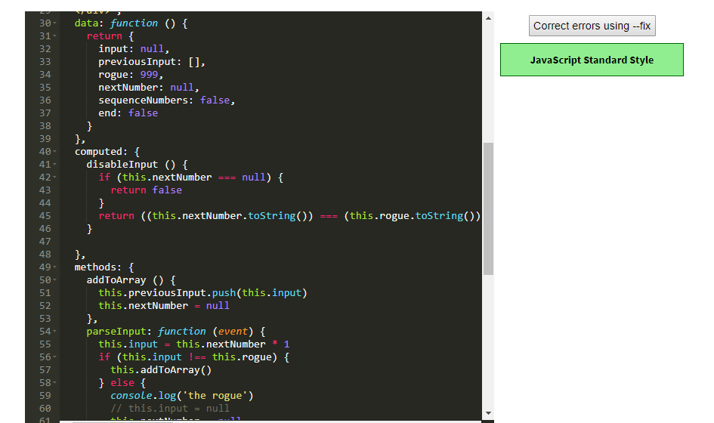

## 6. RUN TEST AND FILL IN TEST RESULT

See attached completed Iteration 5 - Testing Report.docx

## 7. ERROR LOG

See attached Iteration 5 - Defect Log.xlsx

## 8. PROCESS IMPROVEMENT PROPOSALS

See attached Iteration 5 – PIP.docx